Writing Task-1

You should spend about 20 minutes on this task. The charts show the amount and quality of water supplied to two regions of the world.

Summarise the information by selecting and reporting the main features, and make comparisons where relevant.

You should write at least 150 words.

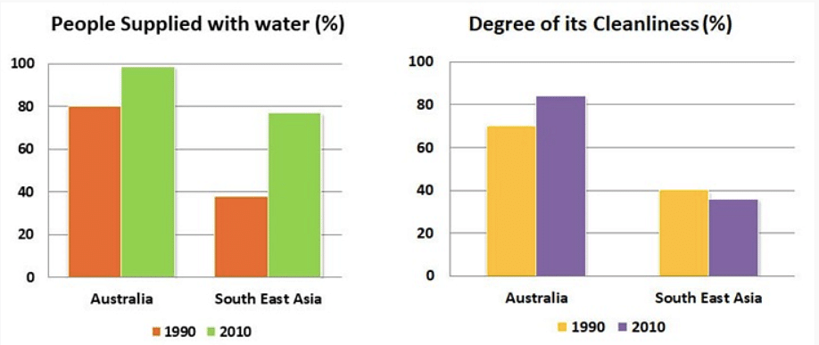

Task-2

You should spend about 40 minutes on this task

The movement of people from the countryside into the cities is happening in many parts of the world resulting in the problems especially in cities. What are the causes of this movement, and how can it be reversed?

You should write at least 250 words.

WRITING
WRITING TASK-1
You should spend about 20 minutes on this task.

Write at least 150 words.
You do not need to write any addresses.
Begin your letter as follows:
Dear…………………..

WRITING TASK-2
You should spend about 40 minutes on this task.
Write about the following topic:
Some people think that there are too many cars on the roads, and that they are spoiling our towns and cities.
Do you agree or disagree?

Give your reasons for your answer, and include any relevant examples from your own knowledge and experience.
Write at least 250 words.

